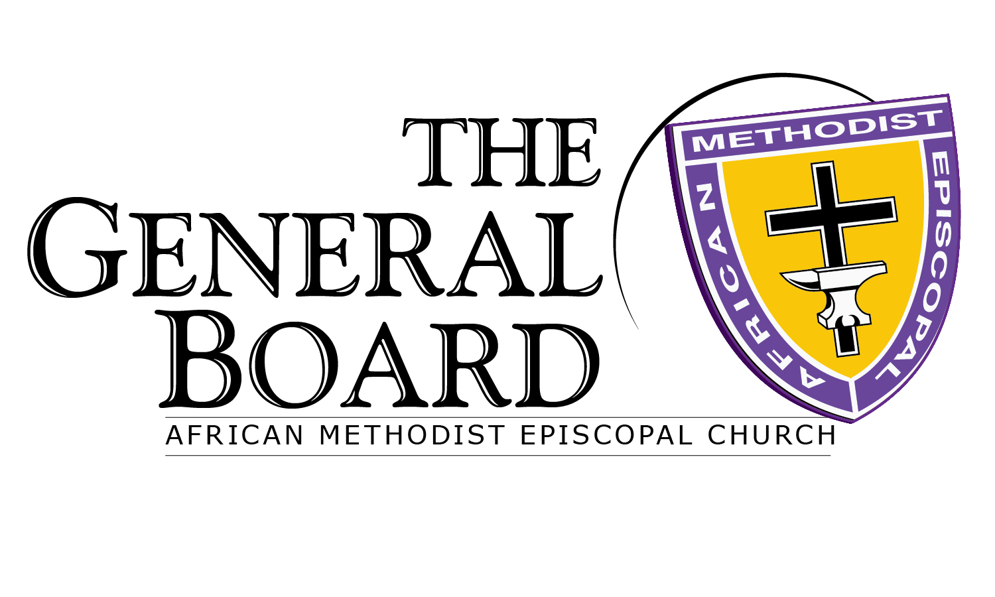
Bishop Richard Franklin Norris, President
The Hilton Riverside Hotel
New Orleans, LA

PRE-GENERAL BOARD ACTIVITIES

SUNDAY, JUNE 28, 2015

5:00 p.m. -- 9:00 p.m. SADA Board Meeting

Monday, June 29, 2015

9:00 a.m. - 11:30 a.m. Council of Bishops Closed Session

2:00 p.m. - 5:00 p.m. Council of Bishops Closed Session

6:00 p.m. - 8:00 p.m. AMEC Board of Trustees

6:00 p.m. - 8:00 p.m. CONN-M-SWAWO Meeting

6:00 p.m. - 8:00 p.m. Presiding Elder’s Council

6:00 p.m. - 8:00 p.m. PK’s Meeting

8:00 p.m. - 9:00 p.m. General Board Caucus Meeting

8:00 p.m. - 10:00 p.m. Council of Bishops Closed Session

GENERAL BOARD AGENDA

Tuesday, June 30, 2015

8:00 a.m. Turner Seminary Breakfast

8:00 a.m. CONN-M-SWAWO Breakfast

9:30 a.m. - 11:15 a.m. General Board Opening Plenary Session

Call to Order Bishop Richard Franklin Norris
President
Devotion
Roll Call Dr. Jeffery B. Cooper
General Secretary/CIO
Felicitations Bishop John Richard Bryant
Senior Bishop
Bishop Julius Harrison McAllister Sr.
President, Council of Bishops and Host Bishop
Acknowledgments Bishop Vashti Murphy McKenzie
1st Vice President, General Board

Approval of Agenda
Minutes
June 2014, Nashville, TN

Meeting APP Ms. Anita Rankin
Logistics Meeting Planner

11:30 a.m. - 12:30 p.m. Commission Meetings – Session I
Ministry and Recruitment
Annuity Investments and Insurance
Global Development
Health
Commission on Chaplains

12:30 p.m. - 2:00 p.m. General Board Luncheon

2:15 p.m. - 3:15 p.m. Commission Meetings -- Session II
Publications
Global Witness & Ministry
Women in Ministry
Christian Education
Economic Development

3:15 p.m. - 4:15 p.m. Commission Meetings – Session III
Seminaries, Universities, Colleges and Schools
Church Growth and Development
Lay Organization
Strategic Planning Committee
Social Action

4:15 p.m. - 5:30 p.m. Commission Meetings -- Session IV
Statistics and Finance

5:30 p.m. Connectional Council Meeting

5:30p.m. - 7:00 p.m. Payne Seminary Reception

7:30 p.m. Council of Bishops Service of Worship &
Investiture Worship Service
Bishop Julius Harrison McAllister Sr.
President, Council of Bishops
President’s Reception (immediately following worship service)
GENERAL BOARD Meeting (continued)

Wednesday, JUly 1, 2015

7:00 a.m. - 9:00 a.m. Episcopal Supervisor’s Breakfast

7:30 a.m. - 9:00 a.m. Jarena Lee Breakfast

9:00 a.m. - 12:00 p.m. General Board Plenary

Call to Order Bishop Richard Franklin Norris
President
Devotion

The Bicentennial Celebration Update

The General Conference Update

Commission Reports
Ministry and Recruitment
Annuity Investments and Insurance
Global Development
Health
Publications
Global Witness and Ministry
Women in Ministry (WIM)
Christian Education
Seminaries, Universities, Colleges & Schools
Church Growth and Development
Lay Organization
Social Action
Economic Development
Statistics and Finance

12:00 Noon – 1:30 p.m. General Board Luncheon

1:30 p.m. - 3:30 p.m. General Board Closing Plenary

Special Statement/Update on
Morris Brown College and
Wilberforce University

Other Business

Adjournment

3:30 p.m. Council of Bishops Public Statement

