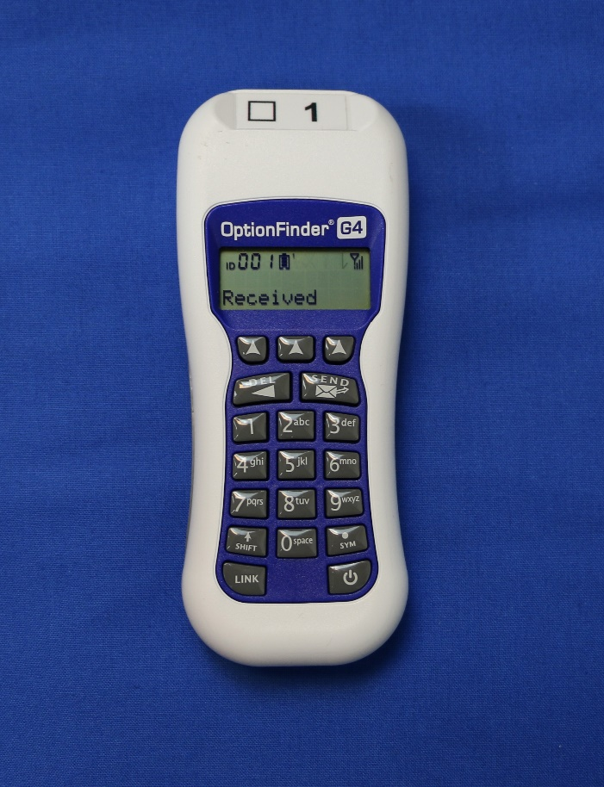

African Methodist Episcopal Church 51st General Conference (2021)
Voting and Elections Committee ~ First Report

PART A
DIRECTIONS FOR VOTING PROCESS
I. INTRODUCTION
During the 51st Quadrennial Session of the AME General Conference we will use electronic handsets to register our votes quickly and accurately. This system has been selected to expedite the voting process, which involves electing candidates, and voting on motions and amendments. By voting electronically, we will be able to reduce the amount of time involved in making these important selections and increase the accuracy of the balloting process.
These voting handsets look a bit like a TV remote control, but instead of pushing buttons to change channels, we’ll be pushing buttons to enter yes, no, and abstain, as well as to elect Bishops and other leaders. For the election of Bishops, you will enter three sets of three-digit numbers using your keypad.
You will enter the number for each of your three selections one candidate position at a time. Each candidate number can be found in the packet list that was sent out with the worksheets for the election of the Episcopal Committee Chairperson, Bishops, General Officers, and Judicial Council Members.
When you enter a candidate number, for example “101” for the number for candidate Jane Doe, the number you enter will be displayed on your handset’s screen. When you press the “Send” button your selection will be wirelessly transmitted to a computer that will record all votes and tabulate the results of each ballot. These results will be checked by the Chair of the Election/Voting Commission after each ballot and then announced by the Presiding Officer.
All your votes will remain private. Each District will be voting in a separate room. The voting keypads in that room are connected to the system via a secure internet link to the host location in Orlando. All delegates in all locations will be voting at the same time.
The leader of your delegation will provide you with your assigned electronic voting handset at the beginning of each business session of the General Conference. The ID number of the keypad will be recorded; however, your personal information will not be linked to your vote.
You will be responsible for returning the unit at the end of each day of the conference to the leader of your delegation. Since electronic voting is new to some delegates, we’ll start the meeting off with “test votes” to get everyone comfortable with the procedure. The Election/Voting Commission Chair will pose a question and give you 60 seconds to vote. During this interval, you’ll be able to change your vote should you wish to do so. The system counts only the last button you pushed: the 1 button for Yes, and the 2 button for No. When the 60-second interval is over, the Chairman will announce that the vote is complete, and shortly thereafter announce the results.
Every vote taken throughout each session of conference will be conducted using electronic voting. Each time, you’ll have 60 seconds to convey your vote. If you don’t want to participate in a particular vote, don’t push any buttons during the 60 second voting interval; if you make a mistake in voting, simply vote again. The system will tabulate the last vote that you enter.
If you input an incorrect number during the voting and you see it on the keypad screen before you press send, and would like to change it press the DEL button on the upper-left to remove one number at a time.
If you inadvertently turn your handset off by pushing the power button in its lower-right corner; push this button again to turn your handset back on. During non-voting portions of the session pressing any other button on your keypad will have no effect on the system. During the voting process any buttons that don’t correspond with the number(s) of selections onscreen will be invalid.
When you leave the conference general session each day, please return your handset to the leader of your delegation. If you forget to turn in your handset, your delegation leader will follow-up with you after the conference and ask you to return it.
Every handset will be tested before the conference, so the probability of a handset failing is very low. That said, if pushing your handset’s 1 button or 2 button during a vote does not produce the word “Received” on its display to confirm that your vote has been tabulated, please let your Episcopal District Election Commission Member know and they will go to the Electronic Voting Help Desk; you’ll be issued a new handset. We don’t expect this to happen, but we are prepared for this eventuality.
If you’re wondering how much radio energy is used by a handset to convey your vote wirelessly, it uses half the power of a typical cell phone and transmits for only a brief instant after you vote by pushing the 1 button or the 2 button, using the same frequencies as Wi-Fi wireless internet access.
If you have any questions regarding the electronic voting systems or procedures, please contact an Election Commission Member or visit the Electronic Voting Help Desk in the rear of the conference hall. Those individuals will be identified in their company uniform.

II. DISTRIBUTION OF KEYPADS
- The voting apparatus (keypad) is stored in a secure container.

- All handsets will be disinfected and placed in a clear disposable plastic bag before distribution. Please leave the handset in the plastic bag when voting.

- The keypads will be distributed and collected in each district by the voting commission persons from each district with the assistance of the General Conference marshals.

- The District marshals will be responsible for the distribution and collection of the keypads from the other voting members, i.e., Bishops, General Officers, etc.

- After collection each day, the handset plastic bags will be discarded, and each unit will be disinfected and repackaged prior to the start of the next day’s business session.

- NOTE: The loss and/or damage of a keypad will cost the individual involved a minimum of $280.00

PART B
ELECTIONS
We, the Voting Commission of the General Conference wish to make this our report to the 51st Session of the General Conference. Our report today will explain our voting procedures and recommend several items which would aid in the implementation of the process.
Following the directive of the General Conference Commission, led on by Bishop John F. White, Sr., we respectfully present to the General Conference the concept of “Electronic voting”; the capacity to simultaneously take a vote of more the 1,600 persons and obtain the result/tabulation of the vote in less than two minutes. This process will not require members of the General Conference to leave their respective seats.
I. RULES
A. The voting process will be explained and demonstrated to the membership of the General Conference. The election processes are explained and demonstrated to the candidates or his/her designee prior to it being explained to the assembly.
B. Those individuals and/or Episcopal Districts requiring additional demonstrations and instructions in the voting process and use of the equipment will be given additional instructions at a designated time and place.
C. The instructions will include but not be limited to (a) an explanation of the process (b) how to use the equipment (c) care of and accounting for the “equipment”.
D. Please refrain from using any personal wireless hot spots during the voting process as this will help eliminate/control possible electronic interference.
E. The General Conference Marshals and Election/Voting Commission will be responsible for the distribution and collection of the voting apparatus in the voting area.
F. The Election and Voting Commission will abide by any additional Rules adopted by this Fifty-First Session of the General Conference of the African Methodist Episcopal Church as it pertains to electioneering.
II. PROCEDURES
A. The candidate’s name, number and categories for the various positions will be shown on the video screen. Each person voting will also have a personal “hard copy” of the information.
B. The voting assembly will be given an appropriate length of time to make his or her choice of candidate in each of the individual categories.
C. The assembly will vote on one and only one category during the appropriate interval.
D. The allocating of appropriate uniform time intervals/breaks between ballots/votes, to allow for “negotiations” will be built into the voting process. (A MAXIMUM OF 30 MINUTES)
E. An area near the stage in the Main Hall will be reserved for the Candidates. Each Candidate is required to submit in writing the name of the person designated to accompany them in negotiations. If that person is a Bishop, the Bishop will remain seated on the stage. If that person is not a Bishop, ONE person so designated will be allowed to be seated in an area reserved for Sponsors. The Sponsor whether a Bishop or not, will be allowed to enter the area of negotiations between ballots for the time allotted. Other campaign workers and supporters must remain in their assigned seat.
F. The Candidate and Sponsor will be allowed to have one cellphone each during the election for the ability to communicate with the assembly.
G. Candidates and campaign workers are NOT allowed to congregate outside of or enter Delegation Meeting Rooms for the purpose of electioneering.
H. The Chair of the Episcopal Committee will be elected during the First Day, Business Session 1. The order of election for others will be as follows: (1) General Officers, (2) Judicial Council, and (3) Bishops.
I. The voting process will proceed uniformly down the ballot until all categories have been voted upon. As results are declared the voting will proceed to the next category. Those categories wherein no one is elected will be held in abeyance until the next “round” of voting.
J. A ballot will consist of a listing of all categories being shown on the screen once. The exception of this rule will be in the category of Judicial Council and Bishop wherein more than one person is to be elected to those positions. Example: If four persons are to be selected to the Judicial Council, that screen must be shown four times with each voter selecting one person from each screen.
K. The results of the vote in each category will be shown on the screen immediately after the votes are tabulated.
L. If a Candidate wishes to withdraw his or her name from consideration, he or she will be allowed to do so during the period between ballots. Prolonged speeches are discouraged. After announcing their intent to withdraw, they must then leave the area reserved for Candidates, and their Sponsor, if not a Bishop, must likewise leave the area and return to their assigned seats among their respective delegation or observer hall.

The Election and Voting Commission humbly requests that the 51st Session of the General Conference of the African Methodist Episcopal, Inc., approves this First Report.

Bishop Clement W. Fugh, Chair

