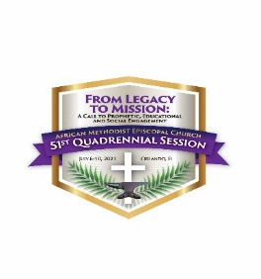
Dear African Methodist Episcopal Church Candidate,

Thank you for your inquiry. All Candidates will receive:

- A complimentary space for 1 (one) complimentary pop-up banner to be set up in a designated area at registration in the Orange County Convention Center (OCCC) on a first come, first served basis.
- A complimentary 30 second video to be aired during the pre-recorded HBCU concert on July 5, 2021.
- An opportunity to participate in an “Eat and Greet” Candidate’s Forum on Wednesday, July 7th.

Additional marketing and sponsorship opportunities are listed below. Unless stated, prices will vary depending on quantity, size and location. Please make your selections by checking the option(s) listed below and return to Karen Osborne at cfo96amec@aol.com.

______ Hotel Guestroom Advertisement in all 4 (four) delegate hotels $2,500.00
    - 5 days, July 6-10, 2021
    - 2 minute spot (maximum)
    - Will air a minimum of 5 times a day

______ AMEC 2021 General Conference Mobile App (please circle choice(s)
Type of Ad | Quantity | Estimated Cost
Splash Screen | 5  (one per day for duration of conference) | $1,300.00
Banner Ad | 10  (twice a day for duration of conference) | $1,000.00
Push Notification | 10  (twice a day for duration of conference) | $1,000.00
Combo Package | 5 Splash Screens (one per day for the duration of the conference)  10 Banner Ads (twice a day for the duration of the conference)  10 Push Notification Ads (twice a day for the duration of the conference) | $3,000.00

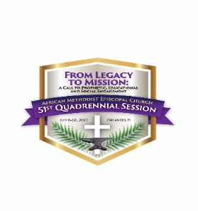

Candidates Marketing and Sponsorship Opportunities (cont’d)

_____ Meal Sponsorship Opportunities
Available for Districts 14 – 20 delegations. Sponsor benefits are signage at door of meeting room, sign on tables and distribution of campaign material.
DISTRICT | DURATION | DESCRIPTION | COST
District 14-20 | Per Day | Lite lunch, coffee break and dinner (SA)  Breakfast and lunch (FL) | $5,000.00  Up to two candidates can share this sponsorship

_____ OCCC sponsored opportunities include window/floor clings, elevators,
selected escalators and designated skywalk areas.

_____ Hotel sponsored opportunities include window/floor clings (in designated
areas).

Please submit this completed form by June 10, 2021. A 50% deposit will be required upon confirmation of your order. Any artwork submissions will be needed by June 15, 2021. For more information email Karen Osborne cfo96amec@aol.com. Thank you.

